
Press Release
For review copies / interviews / use of images / special offers for membership organizations, contact:
gudrun.freese@earthscan.co.uk Tel: +44 (0)20 7121 3152 (direct) 020 7387 8558 (switchboard)

THE ATLAS OF RELIGION
Publication date:
Easter 2007
Mapping Contemporary Challenges and Beliefs

Joanne O’Brien and Martin Palmer
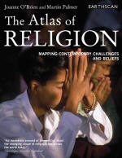
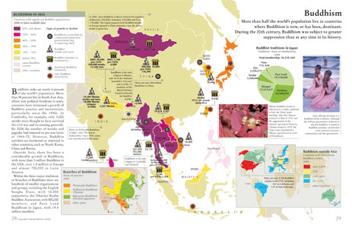

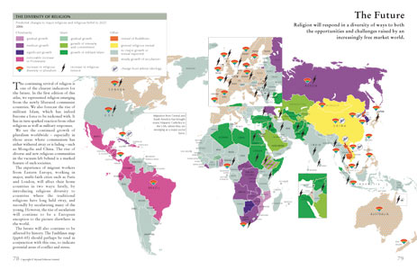

Each spread tells a story – includes 30 maps plus other graphics and tables

Religions are the world’s oldest and largest institutions: they have arguably more impact than any other organisations in the world, and they certainly have more members. This ground-breaking Atlas, compiled and edited by two leading experts on the state of religions around the world - Joanne O’Brian and Martin Palmer - draws upon a unique data base of religious data as well as contact with hundreds of religious organisations around the world. Nothing as comprehensive or as revealing of the power and status of religion has been published in the past decade.

In the past decade the world’s religions have re-emerged as one of the great geopolitical forces shaping our lives. This atlas maps the current impact of major religions, their social role and their diversity.

The Atlas of Religion shows country by country how religions spread their influence through broadcasting, missionary work, schooling and banking; how they relate to government, laws and world hunger; and the role they play in wars.

It traces the emergence of new religious movements, the survival of traditional beliefs, and the presence of atheism and agnosticism. It also maps the origins of each of the major religions as well as their heartlands and the sacred places of the world. For essential background there is also a table on the core beliefs of Buddhism, Christianity, Hinduism, Islam, Judaism, Sikhism and Taoism.

Maps highlighting recent changes in the role of religion (also possible interview topics):

- The dramatic growth of Islamic banking, Christian finance and ethical investment movements within religions is something the wider world has yet to awaken to. (‘Christian Finance’ pp48-49; Ethical Investment’ pp76-77)

- The sheer scale of religious funding and support of those suffering HIV/AIDS, and the level of development funding from Islam and Christianity are rarely acknowledged. (‘Aid and Development’ pp58-59)

- ‘Holy Natural’ (pp84-85) and Environmental Protection’ (pp74-75) record the dramatic rise in the extent and level of the role of religions in the environment movement.

- From marxism to fascism, the expectation developed over the last 100 years was that religion would be thrown aside as an intellectual and social prop that would no longer be needed. Instead it has tended to be ideologies that have faded. The map ‘Emerging from prosecution’ (pp66-67) charts the unprecedented levels of persecution against all major religions that has taken place since the beginning of the 20th century, and the dramatic recovery from such attacks by all the major faiths..

- The majority of the last 100 years saw secular ideologies attacking religions, today that has been replaced by religions attacking secular societies, or in conflict with other religious communities and identities. The map on ‘Faultlines’ (pp 64 – 65) highlights the deep and ancient faultlines that have their origins in religious tensions.

- Other maps / topics include: Popular Religions / Christianity / Islam / Hinduism / Buddhism / Judaism / Sikhism / Traditional Beliefs / Catholicism / New Religious Movements / New Departures / Non-Believers / State Attitudes to Religion / Religious Education / Christian Missionaries / The World / Christian Broadcasting / Islamic Law / Equal Rites / Fundamentals of the Faiths (table)

Facts, Figures & Trends

- Did you know that each year around 73 million new Bibles and 125 million New Testaments are printed - making them still the best-selling books in the world?

- Or that in 2005 one Christian aid agency spent $1.97 billion on relief work around the world, helping people in need, regardless of their faith?

- Or that since 1974, over 300 Islamic Banks – who do not charge interest but take a share in profits instead – have been created, handling $250 billion in assets?

- Or that in the past hundred years, secular ideologies – Marxism, Fascism, nationalism for example – have murdered more members of religions and destroyed more religious buildings and books than in the whole of the rest of recorded history?

- Or that of the 2.2 billion Christians in the world, half are Catholics, making this the largest single organisation in the world?

- Or that in the decade from 1991 to 2001 the number of Hindus in Canada rose by 89%?

- Or that Christian giving in 2005 was £297 billion world wide?

- Or that the major religions of the world own around 7% of the habitable surface of the planet – making them one of the most important stakeholders in environmental issues?

- Or that there are more missionaries per head in the Pacific Islands than there are anywhere else in the world except Greenland?

- Or that many of the world’s current conflicts – the Iraq civil strife; the problems for many in Europe of admitting Muslim Turkey to the EU; that the split between Russia and the rest of Europe – have their roots in religious conflicts dating back in some cases to the 7th century AD?

- Or that more Jews live in the USA than in Israel?

- Or that all these facts and more can be found in the new Atlas of Religion?

Notes to editors

- Joanne O’Brien and Martin Palmer are advisers for the International Consultancy on Religion, Education and Culture (ICOREC) and consultants to WWF, the World Bank, the World Council of Churches, UNESCO and UNDP. Martin is also a broadcaster for the BBC.

- How to credit the book: The Atlas of Religion (£12.99) is published by Earthscan (excl USA / Can). Order online for a 10% discount at www.earthscan.co.uk

- Bibliographic details
The Atlas of Religion: Mapping Contemporary Challenges and Beliefs
Joanne O’Brien and Martin Palmer
Published by Earthscan (2007) / Pb £12.99 / ISBN 978-1-84407-308-5
128pp 189x245mm / Colour maps, figures, tables, index

Published by Earthscan 8-12 Camden High Street London NW1 0JH
www.earthscan.co.uk

